Day 1 : 19-6-2023

ITRODUCTION :

I have choosen the project on image processing using CNN. Convolutional Neural Network(CNN). It is particularly for image classification, object classification and image segmentation.

IMAGE PROCESSING :

Image processing  is the process of transforming an image into a digital form and performing certain operations to get some useful information from it. The image processing system usually treats all images as 2D signals when applying certain predetermined signal processing methods.

Project : Age and Gender Estimation Using CNN

With the increasing usability of cameras and selfies, the number of facial images available in the world has increased. Consequently, there has been a growing interest in automatic age and gender prediction of a person using facial images. Age and gender estimation using face images is an exciting task in the field of computer vision. The traits from the face images are used to determine age and gender. Specifically, this focuses on age estimation and gender classification from images of an individual. We train different models and also used various CNN architectures. It gave the best results.

Reference : <https://www.kaggle.com/datasets/jangedoo/utkface-new>

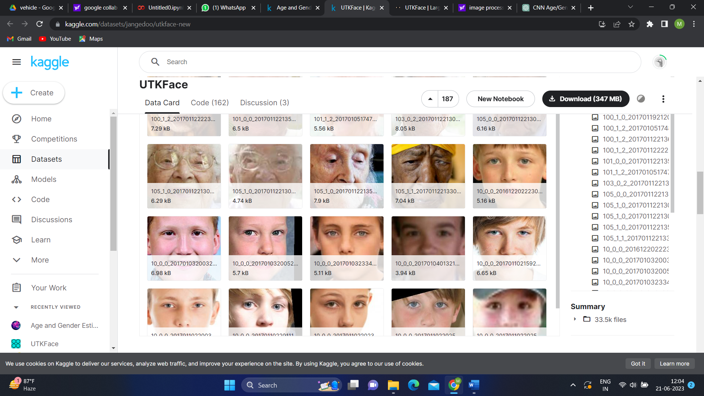

Edit : <https://www.kaggle.com/code/madhumithrar/notebook9cfdbe08c9/edit>

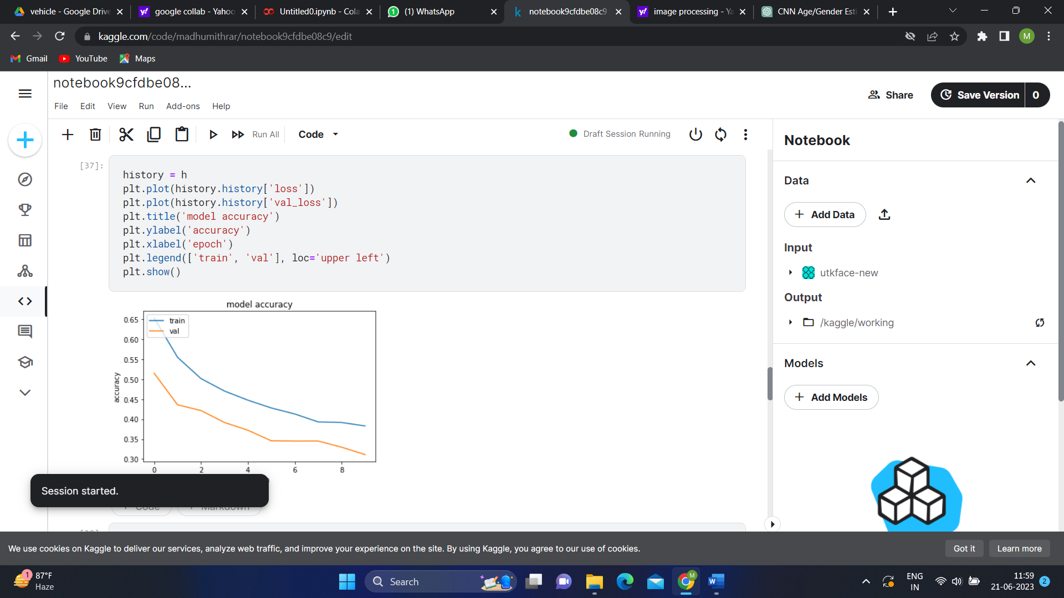

CONCLUSION :

I run the code in Kaggle and get the accuracy. Here the UTKFace dataset is used. Learned to run a code in Kaggle.

Day 2 : 20.6.2023

INTRODUCTION :

The task is to create a dataset. Using google I had downloaded the images using bulk image download extensions.

IMPLEMENTATION  
  
 I have downloaded bike and car images. Uploaded the files in Google Drive. Then combined both files and kept the folder name as “Vehicle”. In that one forth of the images car and bike images are kept as “Test”. The remaining images are in the folder “Train”. Few of the images are taken to “Validation”.

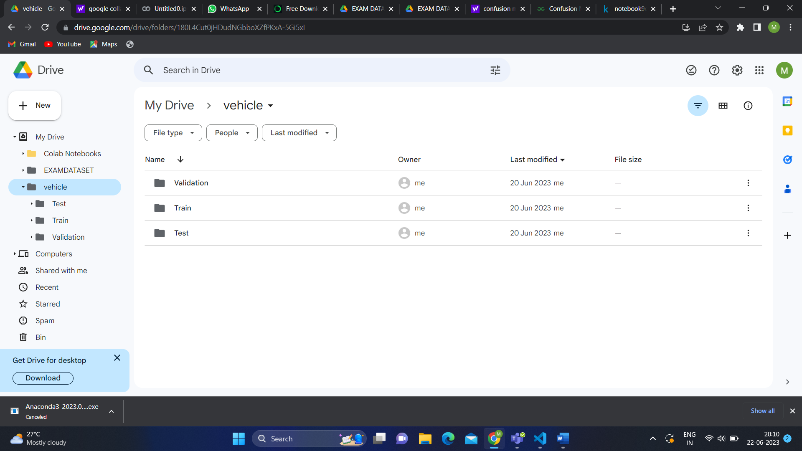

Later , I have connected the drive and google collab. Had run the few codes. There appears some errors and I have cleared the error. Because of errors I got many doubts and the has been clarified. I had came to know the code that is difference for binary class and the multiclass problem.

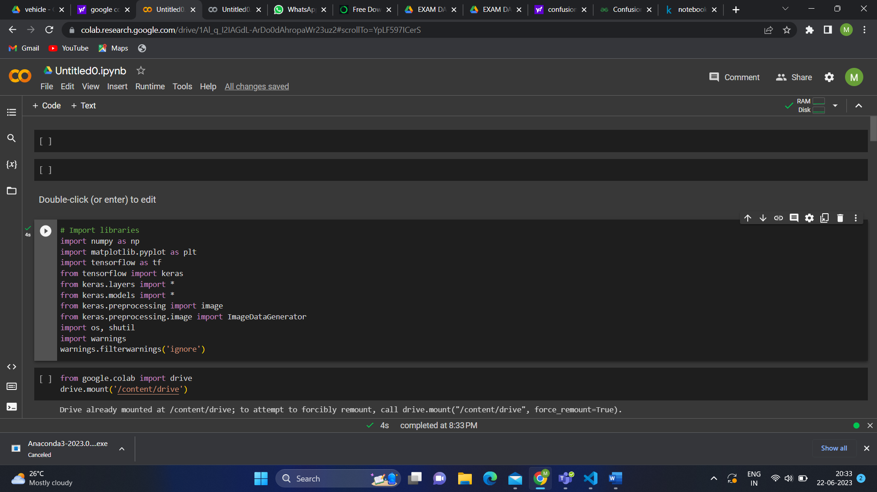

CONCLUSION :

I have got many errors and I cleared the errors by installing the libraries. I came to know about some libraries like keras, tensorflow , etc.

Day 3 : 21.6.2023

INTRODUCTION:

The task is to run the code for given dataset “EXAMDATASET”. It have been done using google collab.

IMPLEMENTATION :

Firstly, libraries has been imported. Keras library has imported. To plot the path of the folder has been copied and pasted.

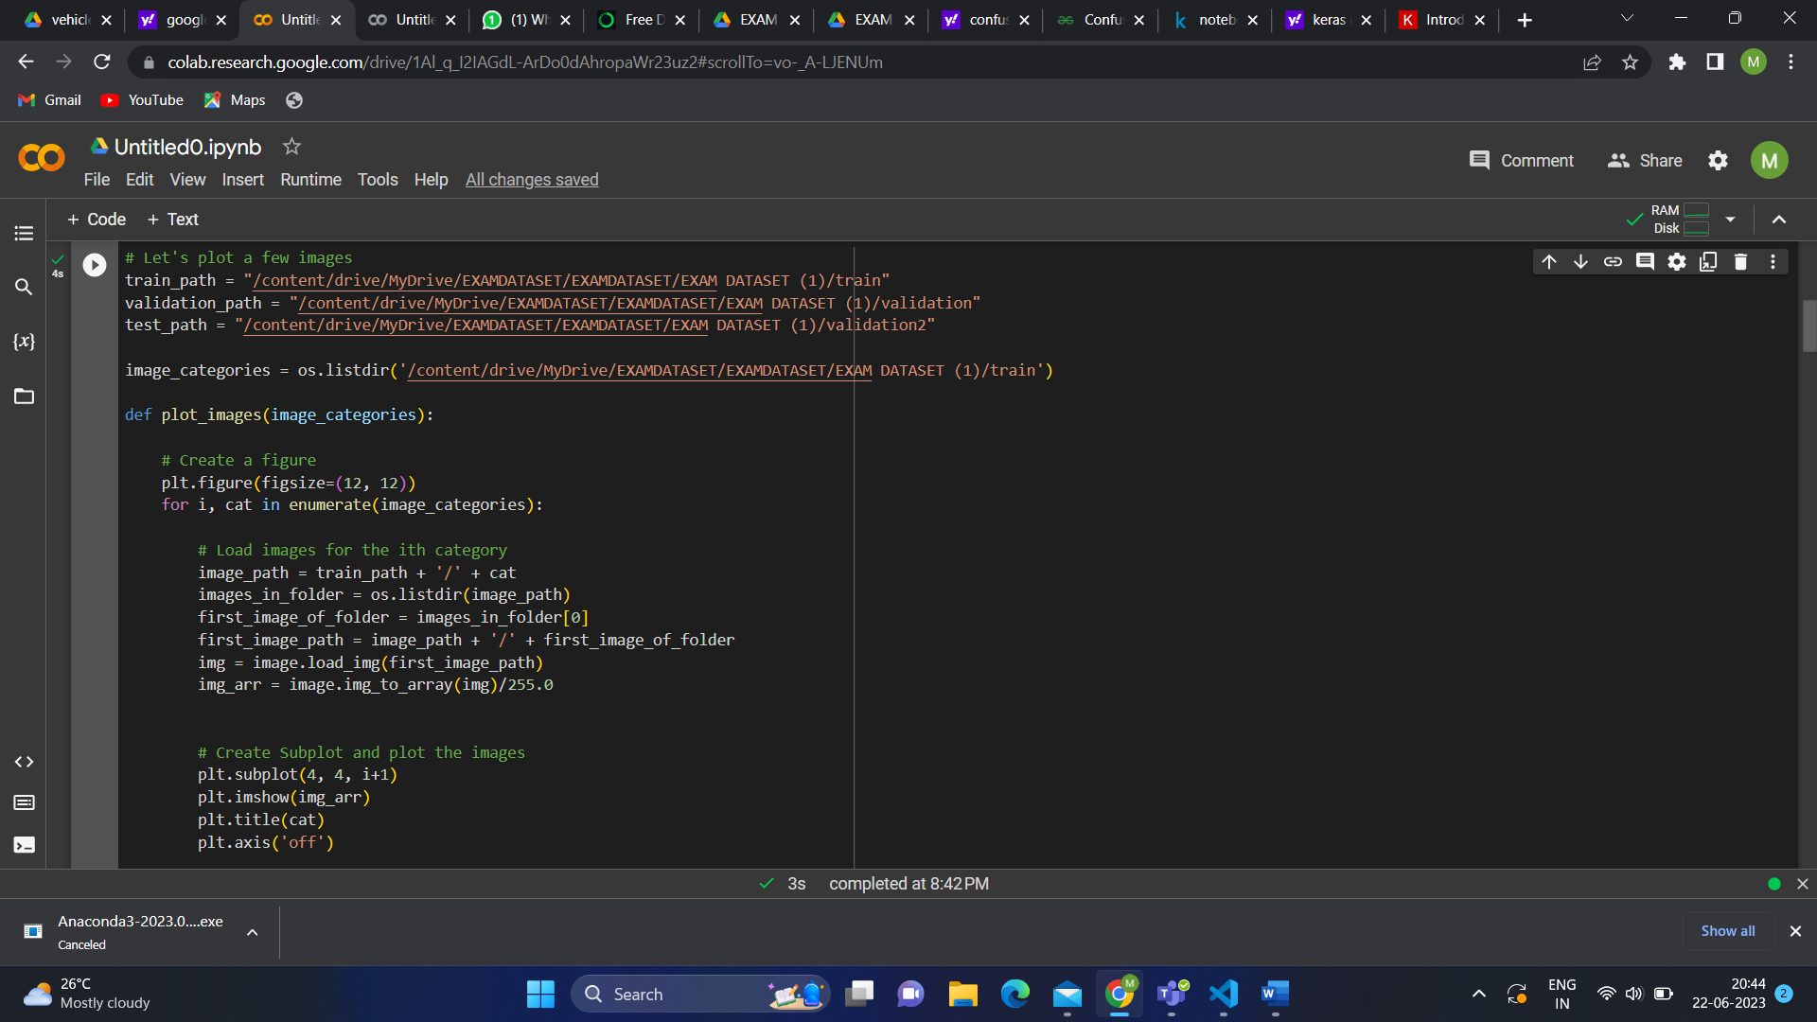

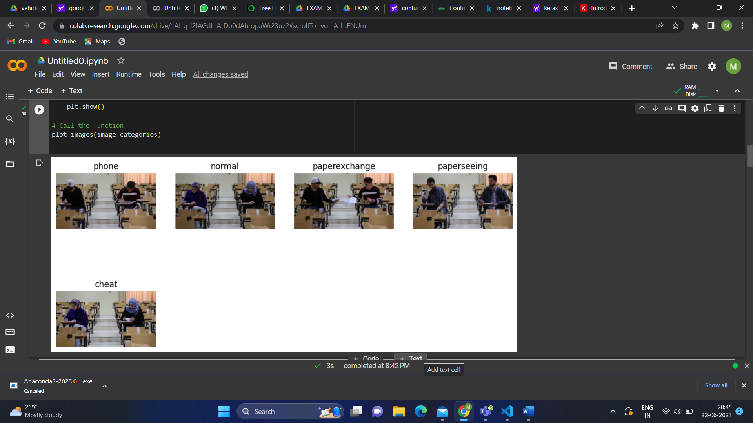

It is a multi class with phone, normal, paper exchange, paper seeing and cheat. The model is build using CNN algorithm.

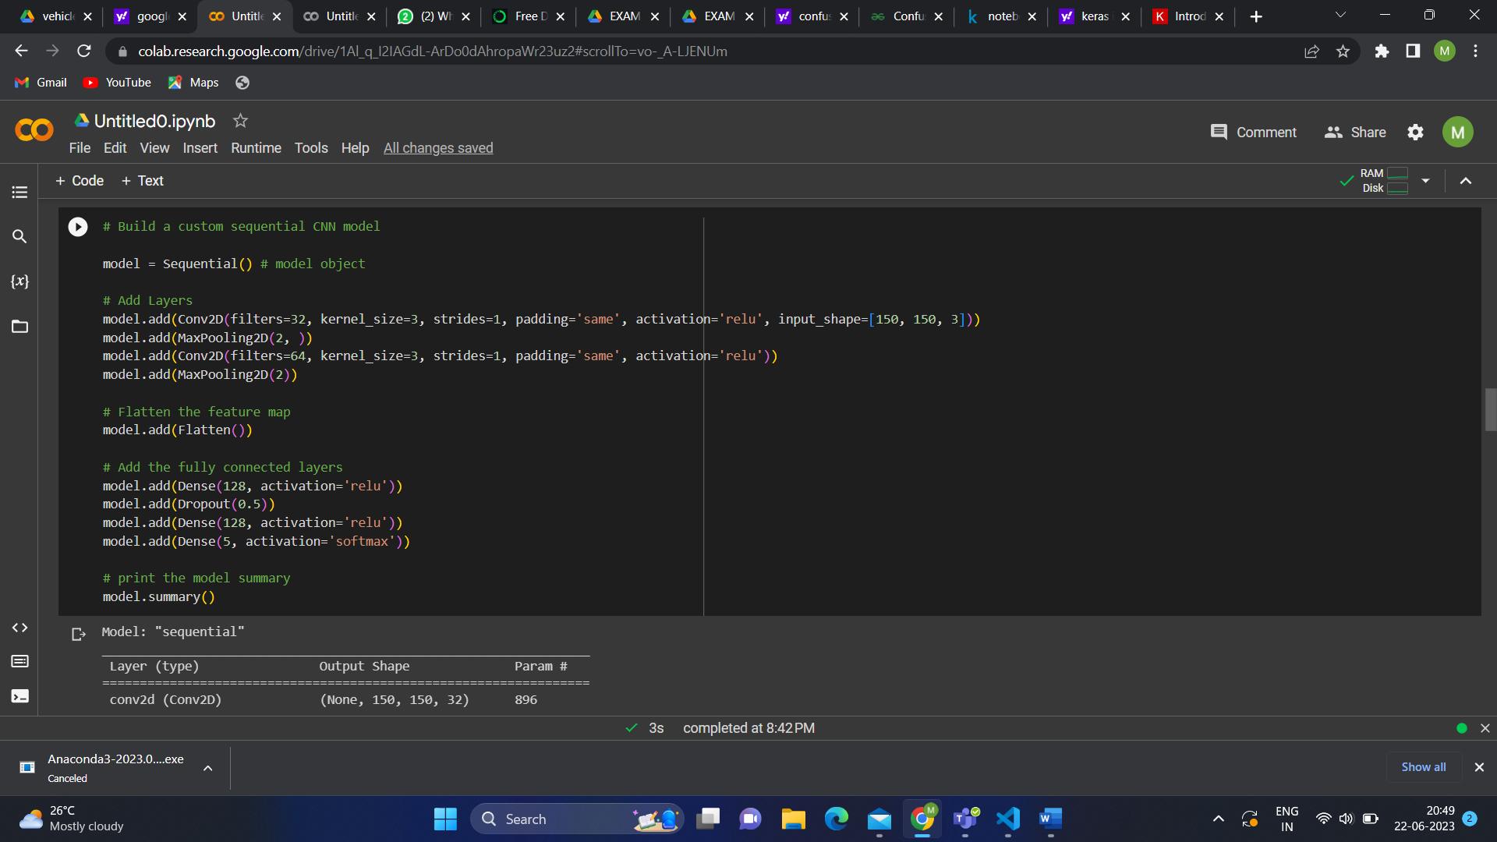

The code for epoch is taken and compiled. It takes more time for epoch. Each epoch takes maximum of 5 to 7 minutes.

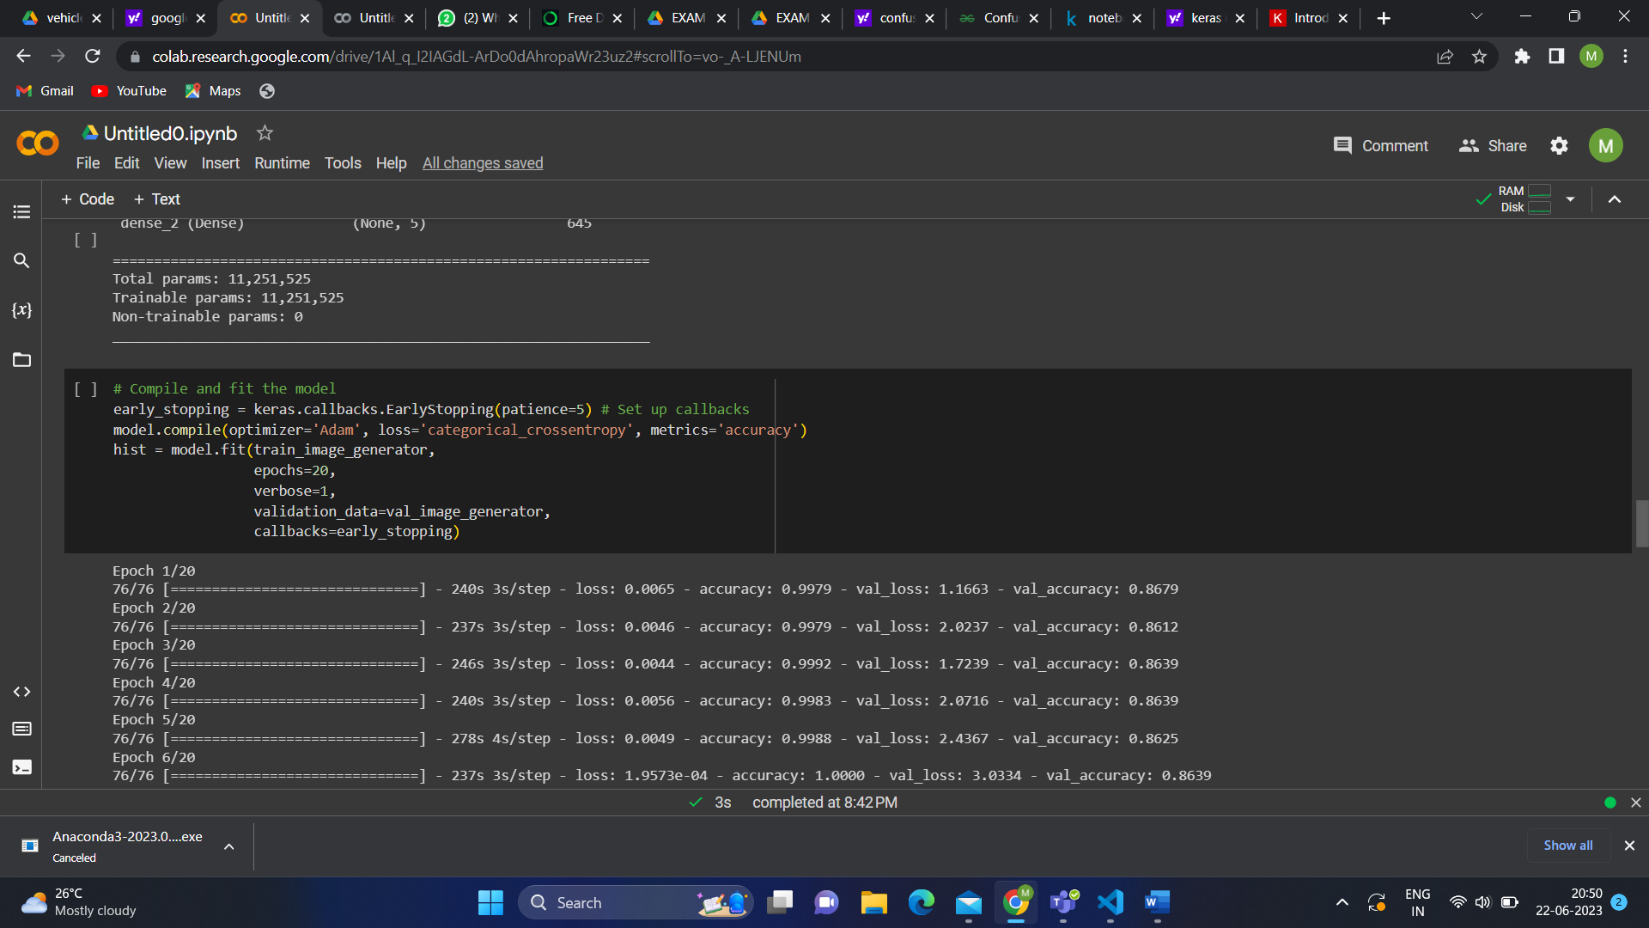

Accuracy and loss for train and validation has been plotted. This may vary according to epochs accuracy and loss values.

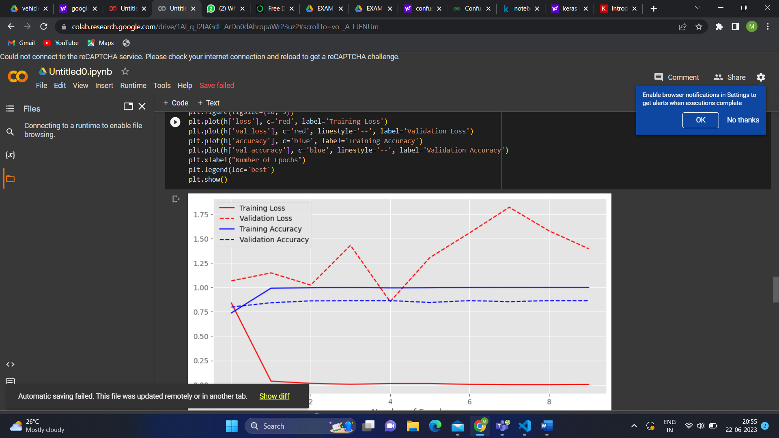

CONCLUSION :

I have completed up to confusion matix.

Day 4 : 22.6.2023

INTRODUCTION :

Based on previous day’s work there is doubt in confusion matrix. I searched about it in the google to gain knowledge about it.

CONFUSION MATRIX :

Confusion matrix summarizes the performance of machine learning model on the test data set. The matrix displays the number of true positive, true negative , false positive and false negative produced by model on the test data. For binary classification, the confusion matrix will be 2x2 table. For multi class, the confusion matrix may vary based on the table size.

Confusion matrix :

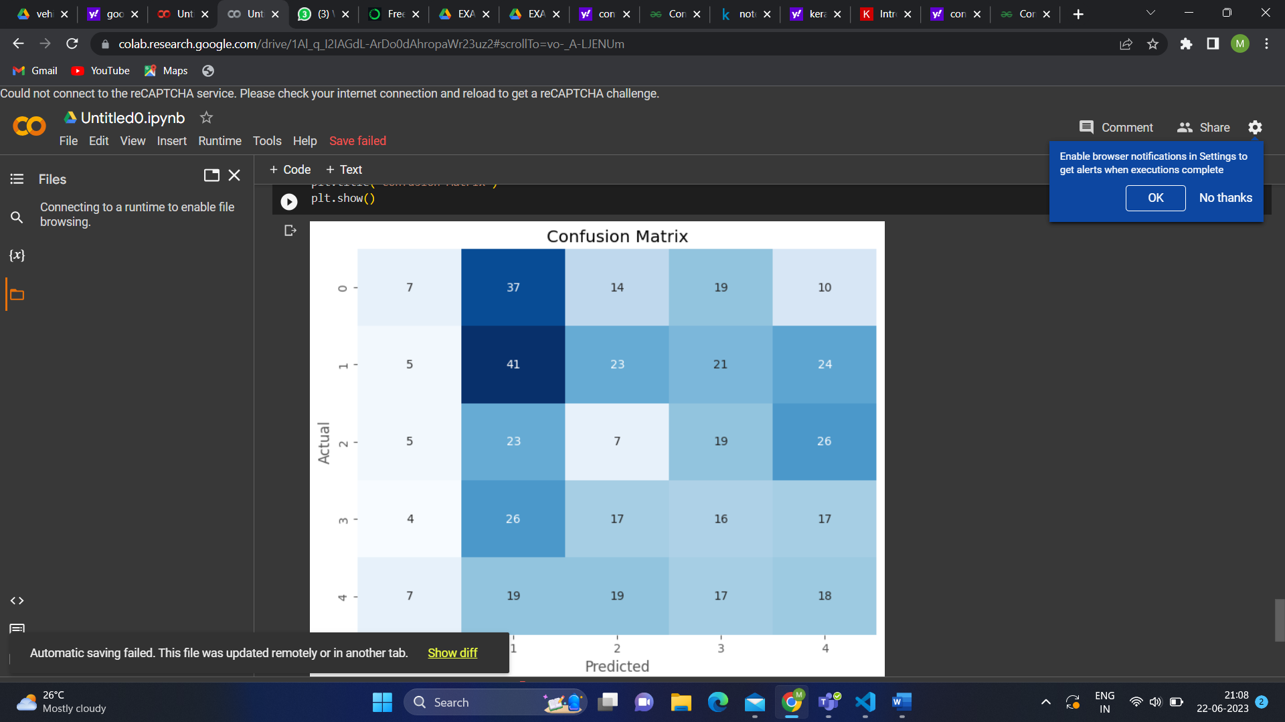

CONCLUSION :

I got the result in confusion matrix. It has predicted a wrong value. I have tried to implement it again to get a approximated output.

Day 5 : 23.06.2023

INTRODUCTION :

The task is to run various algorithm. I searched for the code and copied it in the word.

IMPLEMENTATION :

There are many types of CNN models. LeNet , ResNet , MobileNet , VGG and AlexNet.

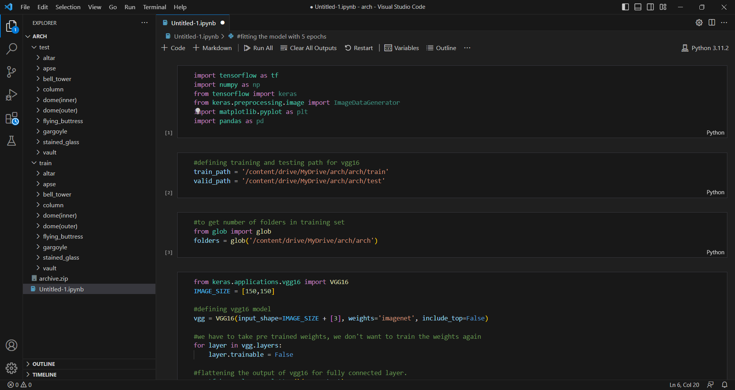

CONCLUSION :

I collected the codes and I executed the code of VGG model.

Day 6 : 24.06.2023

INTRODUCTION :

The code for VGG is executing. It takes more time to run the epoch.

IMPLEMENTATION :

It is a multi class dataset. It has 10 classes in the dataset. The code for VGG 16 pretrained model with 0.01 learning rate with 100 epochs and batch size of 64 and achieved accuracy of 92 percent approximately.

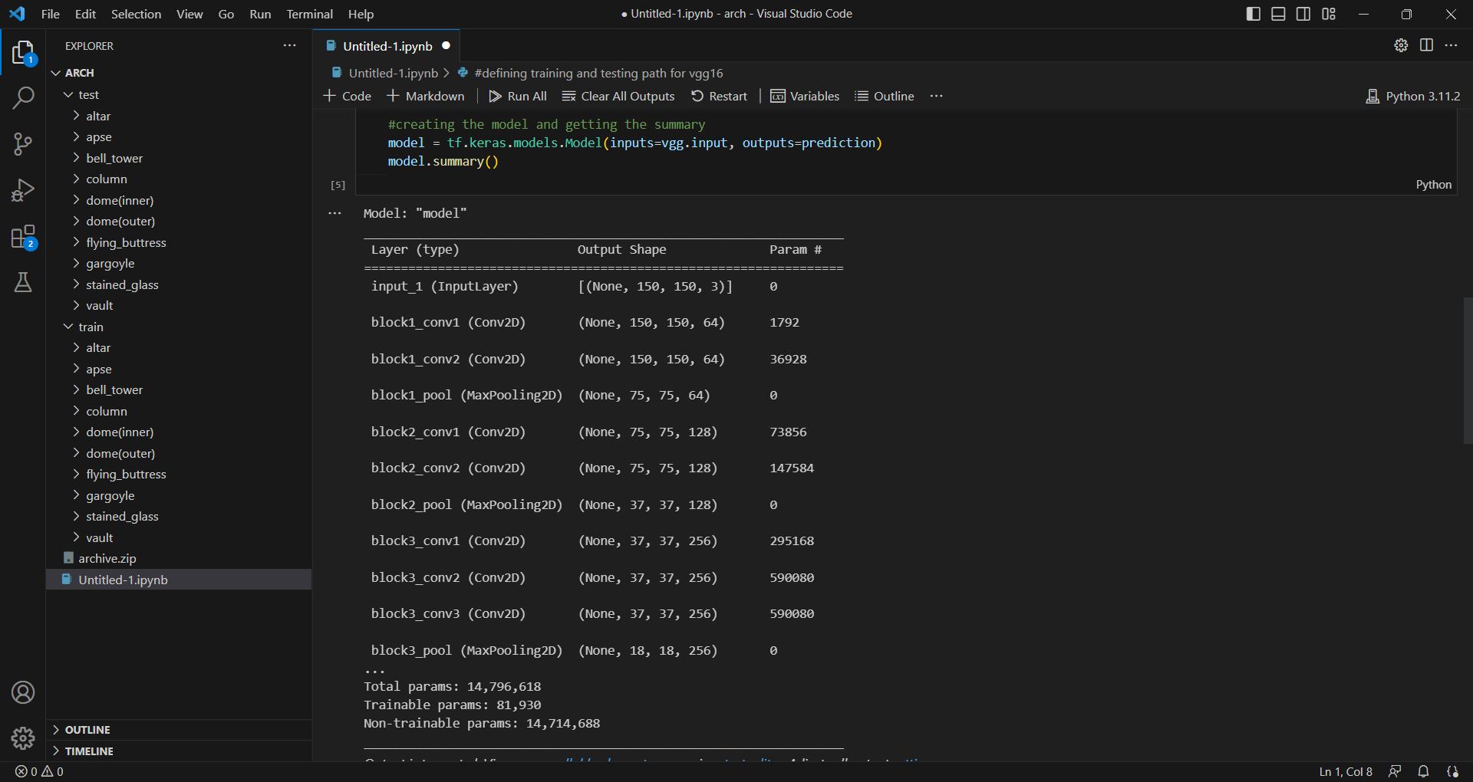

Epoch takes more time.

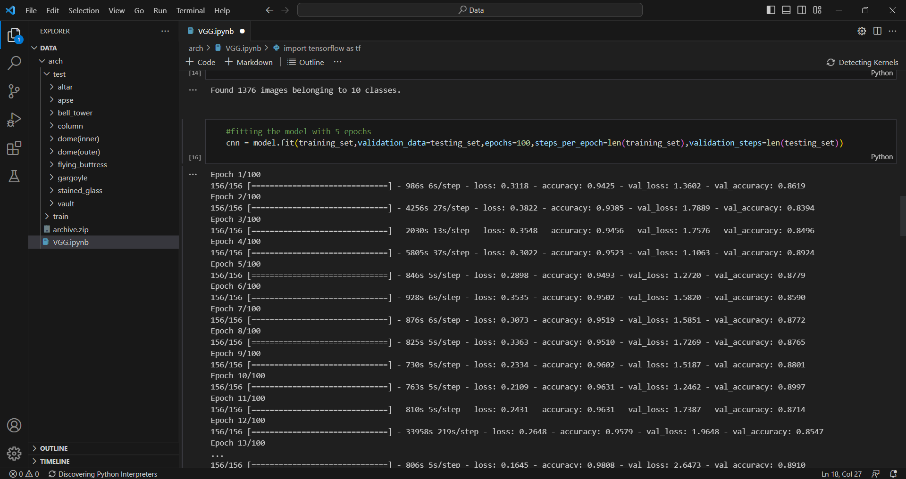

Confusion matrix which I got is approximately wrong.

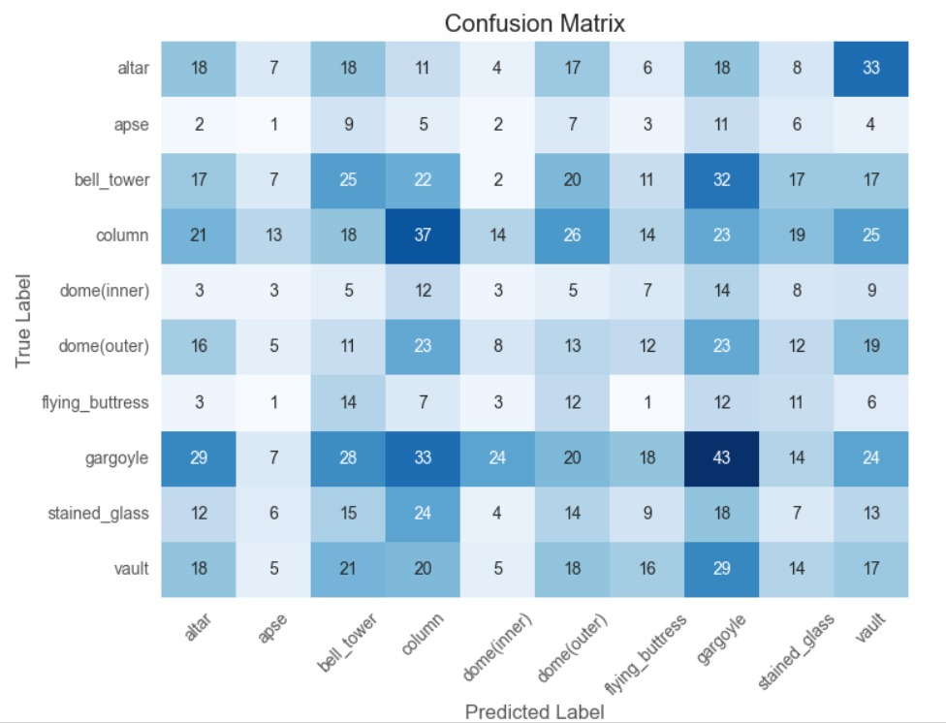

CONCLUSION :

Learnt about VGG16 architecture and how it works with a learning rate of 0.01 with a batch size of 64 and trained 100 epochs.

DAY 7 : 25.06.2023

INTRODUCTION :

I learnt about the algorithm Mobile net, ResNet. I executed the code for Mobile net, ResNet algorithms using the same dataset to compare the accuracy.

IMPLEMENTATION :

ResNet and MobileNet are the convolutional neural networks commonly used for an image classification task.

MOBILE NET :

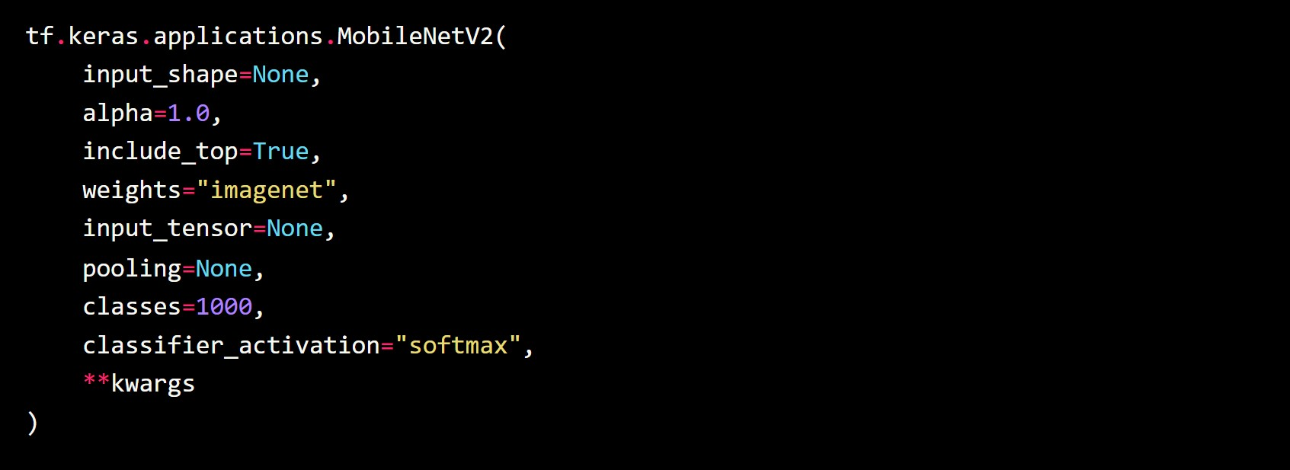

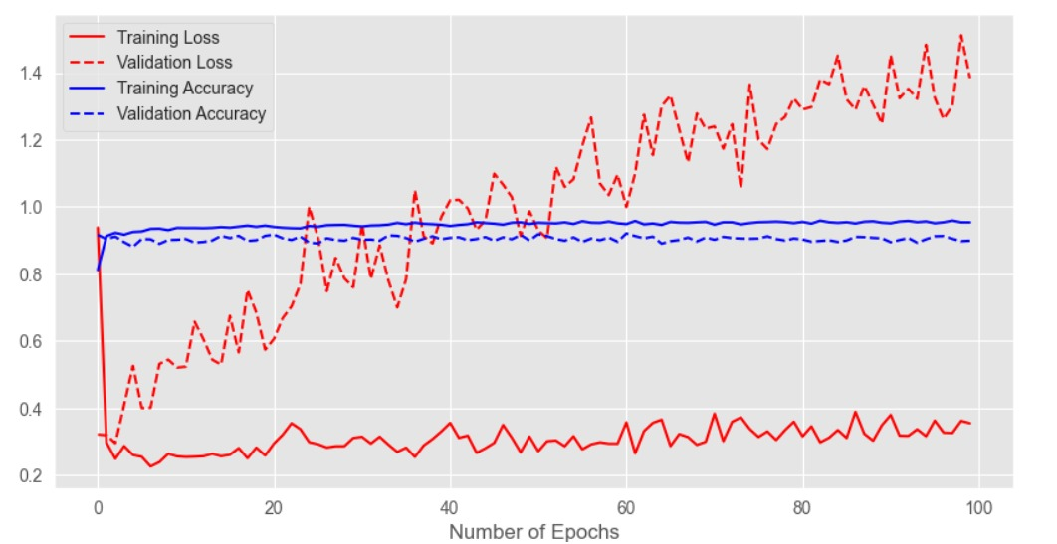

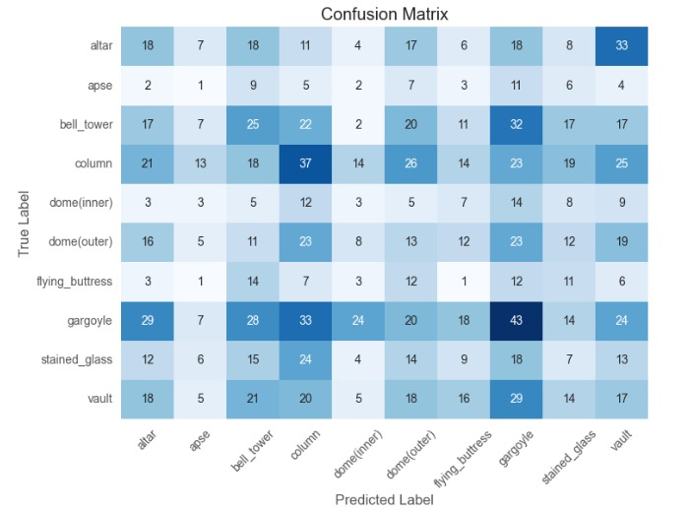

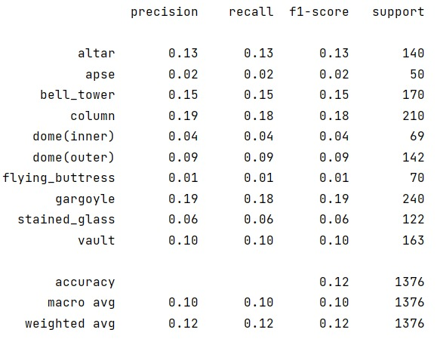

RESNET :

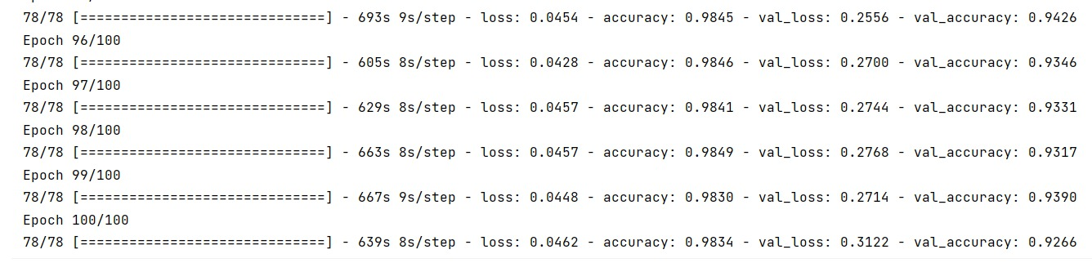

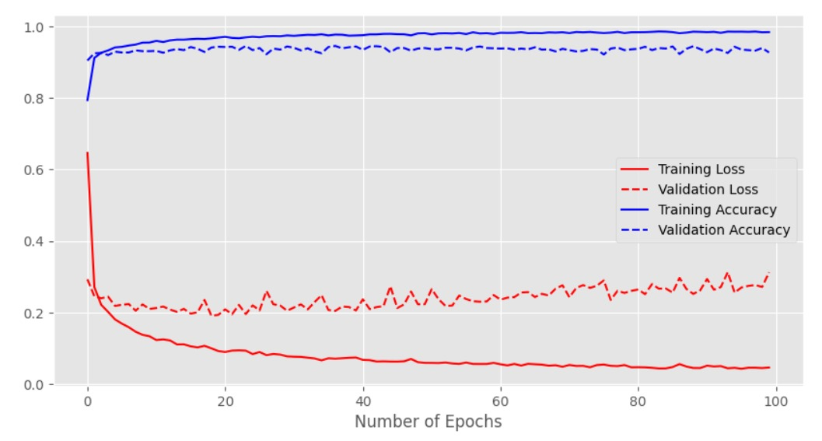

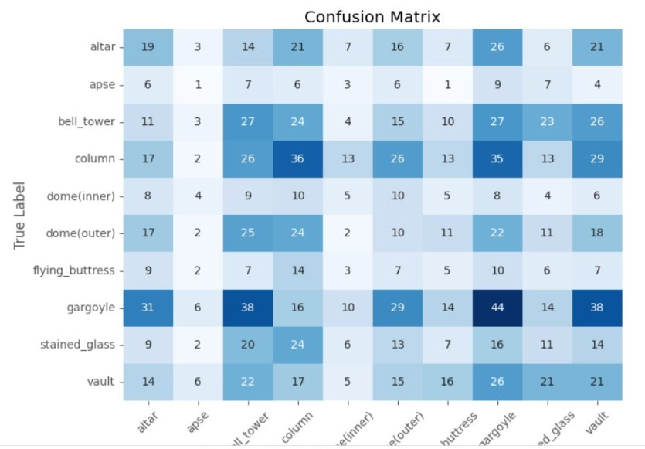

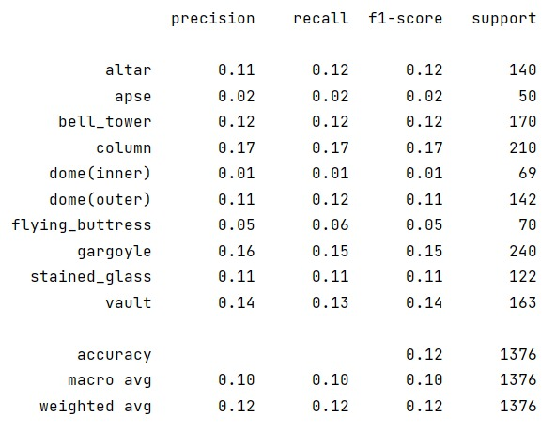

CONCLUSION :

It takes more time for epoch. The code for Mobile net and ResNet pretrained model with 0.01 learning rate with 100 epochs and batch size of 64 and achieved accuracy of 86 percent approximately.